  - Odds Ratio Model

In the odds ratio model, we decided on binarizing nearly all NEPSY-II scores with a threshold of greater than five vs less than or equal to five, as this is ‘below expected’ on the NEPSY scale. For ISC, we chose a cutoff of greater than six versus less than or equal to six get similar percentiles with those of IIC and INC. We found statistically significant results for IIC, INC, ISC, CITS and MFFTS scores (Figure 2).

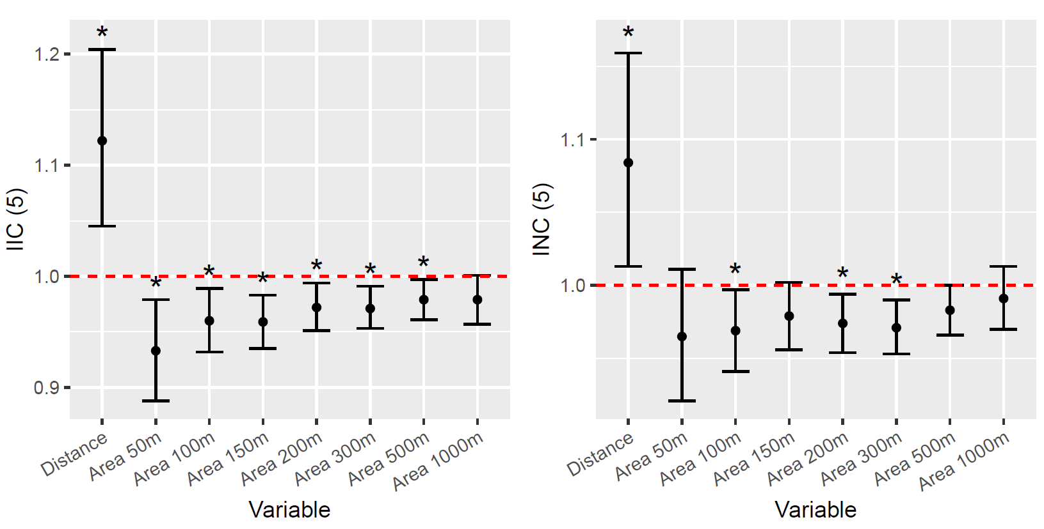

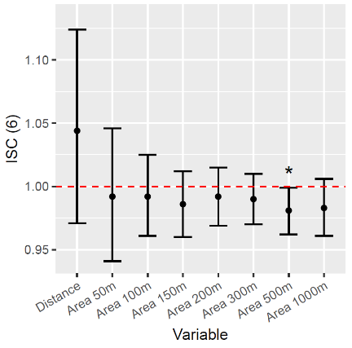
​​ 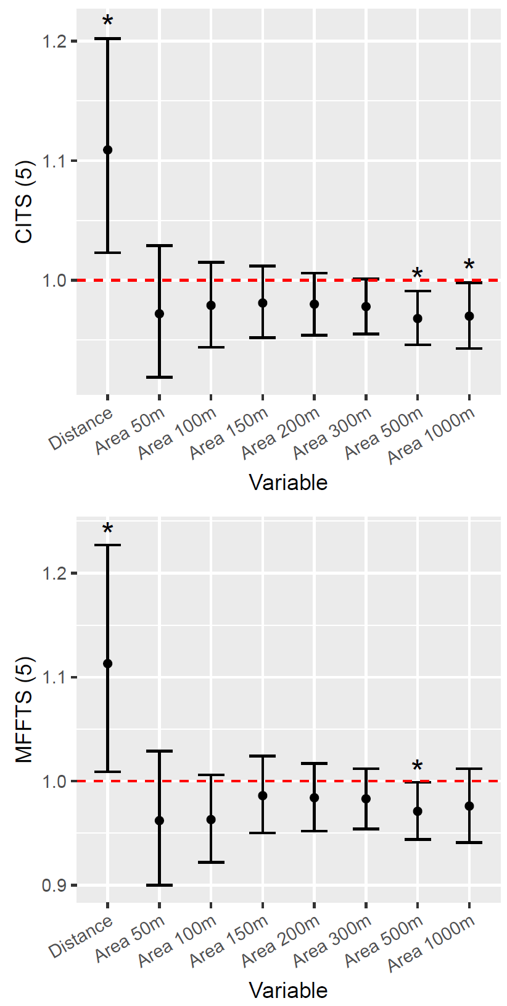
Figure 2: Odds ratio of having a high NEPSY-II score (reference: low score) after doubling distance or area variable for select NEPSY-II scores and subdomains. The odds ratio is indicated by a point with a 95% confidence interval. To binarize NEPSY-II scores, a high score is a score that is greater than the value indicated in the title/axis label of each graph (e.g. 5 or 6).

The IIC score was found to be significantly associated with distance from residency to nearest plantation and all crop area variables between 50m and 500m, to understand levels of proximity and differences in exposure. Doubling distance increased the odds of having a high IIC score by a factor of 1.122 (95% CI: 1.045, 1.204), while doubling greenhouse area under 150 m had the highest statistical significance (p-value = 9.25e-4) and changed the odds ratio of a high IIC score by a factor of 0.959 (95% CI: 0.935, 0.983). The INC score was found to be significantly associated with distance from residency to nearest plantation as well as areas under 100m, 200m, and 300m radii values. Doubling distance changed the odds ratio of a high INC score by a factor of 1.084 (95% CI: 1.013, 1.159), while doubling greenhouse area under 300m had the highest significance (p-value = 2.22e-3) and changed the odds ratio of a high INC score by a factor of 0.971 (95% CI: 0.953, 0.990). The ISC score was only found to be significant in crop areas under 500m. Doubling crop areas under 500m led to a change in the odds ratio of a high ISC score by 0.981 (95% CI: 0.962, 0.999).

In the Language domain, the CITS score was found to be significantly associated with distance from residency to nearest plantation, and crop areas under 500m and 1000m. Doubling distance changed the odds ratio of a high CITS score by a factor of 1.109 (95% CI: 1.023, 1.202), while doubling area under 500m had the highest significance (p-value = 6.36e-3) and changed the odds ratio of a high CITS score by a factor of 0.968 (95% CI: 0.946, 0.991).

In the Memory and Learning domain, the MFFTS score was found to be significantly associated with distance from residency to nearest plantation and crop areas under 500m. Doubling distance and doubling area under 500m changed the odds ratio of a high MFFTS score by a factor of 1.113 (95% CI: 1.009, 1.227) and 0.971 (95% CI: 0.944, 0.999) respectively.

